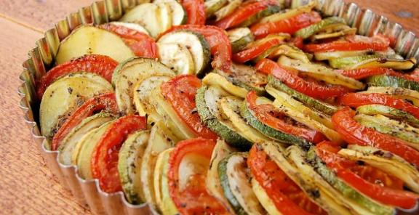

**Colorful Vegetable Tian**

Kitchen Belleicious

Feeds 6

**Ingredients**  
1 large or 2 medium russet potatoes  
1 large squash  
1 large zucchini  
1 large red bell pepper  
1 small onion, diced  
3 cloves garlic, minced  
1 TBSP Spanish thyme  
1/2 tsp paprika  
1/2 tsp oregano  
1 TBSP mustard  
2 tsp olive oil  
1 tsp balsamic vinegar  
1/2 tsp salt and pepper each  
1 TBSP freshly chopped basil or parsley  
2-3 TBSP Romano cheese

**Directions**  
Sauté the onion, garlic and red bell peppers in the olive oil for 5-6 minutes until slightly translucent. Place in the bottom of a round casserole dish or tart pan. Sprinkle with Romano cheese and basil.  
Slice the potatoes, tomatoes, squash and zucchini in round 1/4 inch thick slices. In a large mixing bowl, stir together the mustard, balsamic vinegar, salt, pepper, paprika, thyme and oregano. Layer them alternatively in a circular motion on top of the onion mixture. Make sure to fit them in tightly and create a spiral. Bake at 350 degrees F covered with foil for 30-40 minutes. Remove the foil and bake for another 10-15 minutes.